# 



Series AS400

External Vendor Install Process

# Revision History:

|  |  |  |  |
| --- | --- | --- | --- |
| **Revision Date** | **Version Number** | **Description of Change** | **Updated By** |
| 06/24/2015 | 1.0 | Document draft | Miguel Muniz |
|  |  |  |  |
|  |  |  |  |
|  |  |  |  |
|  |  |  |  |
|  |  |  |  |

# Overview

This document is to establish a general instructions set for installing Series on none AHS machines.

# Purpose

This document is to assist a Vendor IT person in installing Series properly outside the AHS network.

# End-User Computing (EUC) Role

EUC is responsible for provide the vendors IT department with this documentation and the installation files.

# Documents/Reference Material

Will be provided via SFTP or other sharing platform

**Left Intentionally Blank**

You should by now have all needed files for the installation if this is not the case please reach out to the EUC technician you have been working with for that person to provide the needed files

**List of files**

1. Installation file
2. Service Packs
   1. 32bit
   2. 64bit
3. Series Session Icons

* The total size should be around 3.80 GB – this will vary as we update service packs and or clean up the installation files
* Note that the files have been label with a number allowing easy identification of which service pack comes first, last, etc.

**Installation prerequisites**

* Admin rights needed
* Enough space on your user computer to complete the setup and service pack install

**Installation Steps**

**Package installation:**

1. Download the Series Installation.zip file from <http://www.techryan.com/kiwi-tek/downloads/Adventist>
2. Unzip the downloaded file
3. Find the “1 – Install” folder Inside find “Setup.exe” and double click to execute
4. IMPORTANT choose all the defaults and verify the installation type is COMPLETE
5. Reboot once completed **Required**

**Service Pack Installation:**

1. You should have two folders label 32bit or 64bit pick the appropriate one for your user
2. Two files need to be run in order to properly install the Service Packs
   1. See Example below, run #1 then #2, etc.
      1. 
3. Choose the default for the service pack install and select YES on any other prompts

**Configuration:**

**NOTE: if you used the “series session icon” pack you can skip this step. You can drop the icons from the Series Session Icon folder on to the user’s desktop. The icons are preconfigured. If you need to create a new session, the steps are listed below.**

1. Launch session configurator – All Programs > IBM iAccess for windows > Emulator > Start or Configure Sessions
2. Click > File > Change Directory to: C:\Program Files\IBM\Client Access\Emulator\Private
3. Select “New Session” - REPEAT for multiple sessions example SUNBELT / SSCIFWDC

Steps to configure:

1. Under system name type: Sunbelt or SSCIFWDC
2. Specify workstation ID – type the user’s computer name – name must be unique

**Workstation ID:** You must increase the letter at the end by one – example first session is “a” the second sessions is “b” – if more sessions are needed you just need to increase the letter to the next in this case “c”, etc. - Using the example below session “b” will be: AHCLEUS22b

1. Select “Auto-Reconnect”
2. Size “37x132”
3. Hit “OK” and continue with step #6

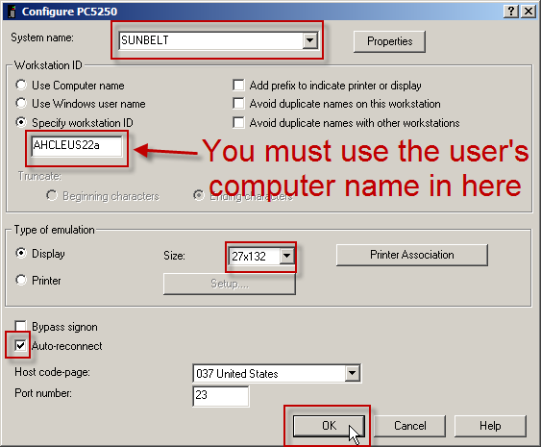

1. Choose “Prompt every time”
2. If the user is available have them login with their credentials or click cancel
3. Go to file > Exit, when prompted choose YES – DO NOT SKIP this step
4. Save the session on the following path (see below)

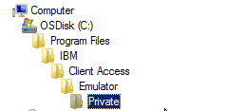

1. Change the name to match your session name – SUNBELT/SSCIFWDC – **NOTE: if you used the “series session icon” pack you can skip this step**