NHA Cisco SSL VPN Connection Instructions

Step 1

Open a browser and go to https://216.84.26.66. A certificate error screen will pop up. Click on the link to “Continue to this website”.

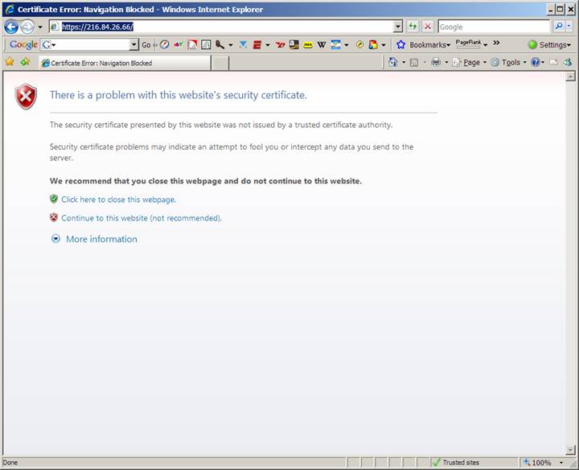
Step 2

Enter your Windows username and password and click on the Login button.

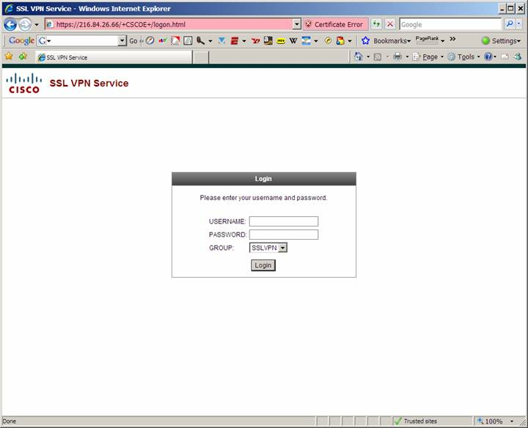

Step 3

You may receive a notification at the top of your browser asking if you want to download the file. Download the file and select Run. The SSL client install will begin and will load on its own.

Step 4

You will receive the following Certificate error. Click on the Yes button.

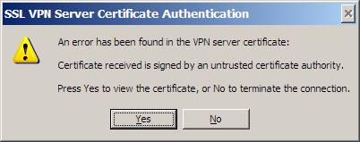
Step 5

Install the certificate by clicking on the Install Certificate button.

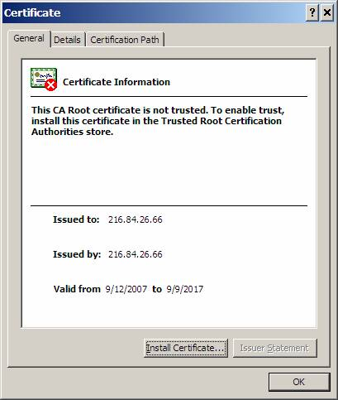

Step 6

Click on the Next button.



Step 7

Click on the Next button.

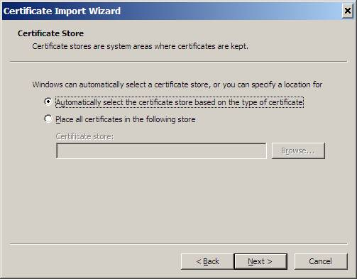

Step 8

Click on the Finish button.



Step 9

Click on the Yes button.

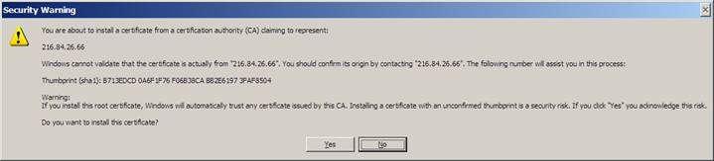

Step 10

Click on the OK button.

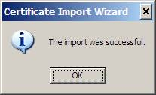

Step 11

Click on the OK button.

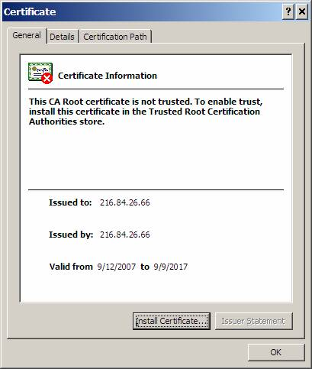
Step 12

Click on the Yes button.

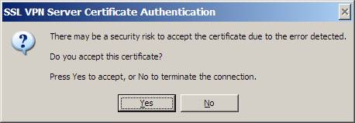

Your connection is established if you see a yellow key in the lower right corner of your screen. After this you will only have to enter your Windows login information to establish a connection.

Step 13

Go to Start -> All Programs -> Accessories -> Remote Desktop Connect

When the Remote Desktop Connection window appears type in the following GH-TERMSERV1 and after you have entered the computer name press Connect.

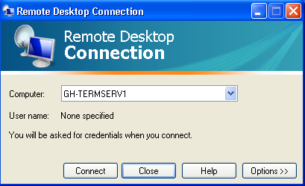

You should now be able to log in to the terminal server.

