To access CPSI it will be a two step process.

1. Connect using the Cisco VPN Client
2. Run the RDP client – This will automatically run CPSI from our server.

3. To run the 2nd (stand-alone) CPSI client, go to http://www.techryan.com/kiwi-tek/downloads/Roxborough/cnCWSetup17.exe and download. See screenshot below for connection details.

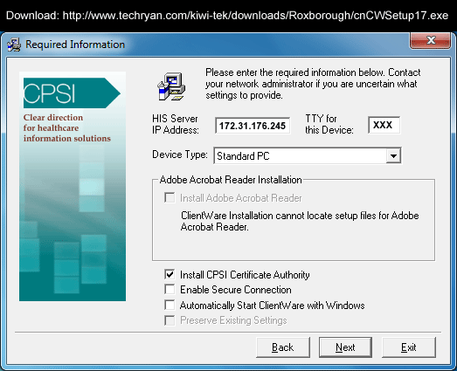

Mike Gaglianone
Director of Information Services
Roxborough Memorial Hospital
5800 Ridge Avenue | Philadelphia, PA 19128
T: 215-487-4560 | F: 215-487-4332 | E: mgaglianone@primehealthcare.com

