# STVHS Citrix Full VPN Client Installation Walkthrough

Please Note: The first steps of this walkthrough involve uninstalling the old Positive Networks VPN Client. If you do not currently have the Positive Networks VPN Client installed, please ignore the first section and proceed directly to the STVHS Citrix Full VPN Client Installation section.

**DOMAIN: bhmstv**

**Uninstalling the Positive VPN Client**

1. Click on Start and open the Control Panel

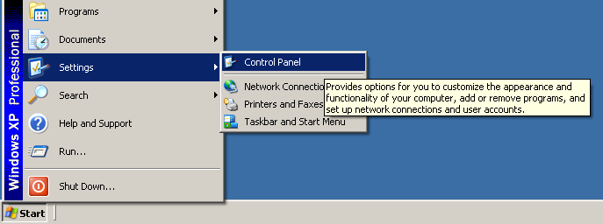

1. Open ‘Add or Remove Programs’

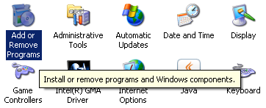

1. Select ‘ANX PositivePRO’ from the list and select Remove

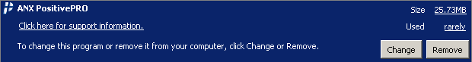

1. Confirm any uninstallation notifications and proceed with the uninstall until it is complete
2. Restart your PC if the uninstallation process does not prompt you to do so
3. Confirm the Positive VPN Client is uninstalled by checking for the ‘P’ icon in the taskbar and/or its presence in Programs on the Start Menu

**STVHS Citrix Full VPN Client Installation Instructions**

1. Connect to the internet **OFF SITE** with your **STVHS** **PC** and browse to <https://vpn.stvhs.com>
2. Login with your **ALBIR** username and password

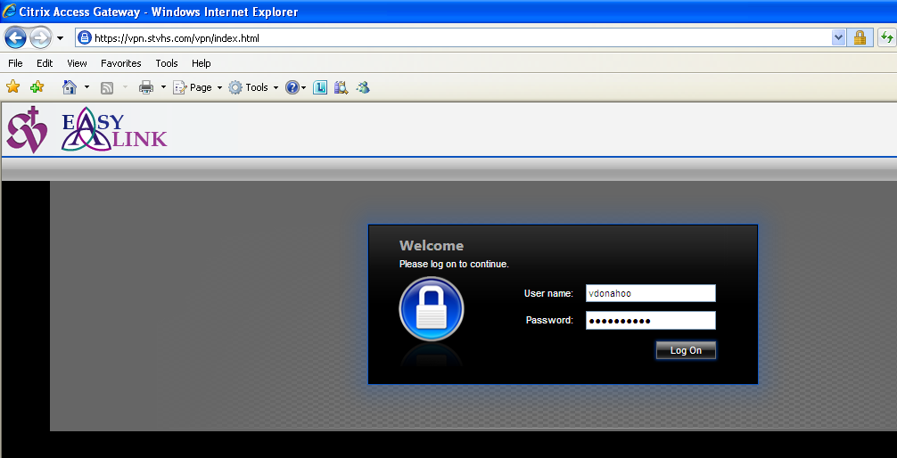

1. You will be prompted to install the **Citrix VPN Client** if it is not already installed
   1. Click on the Download button to start the installation process

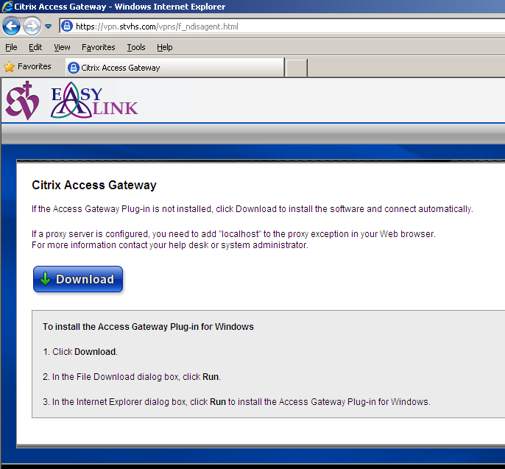

* 1. Select Run

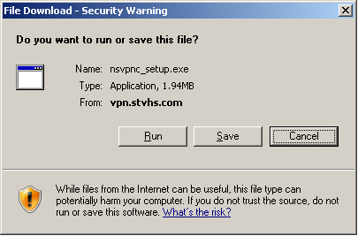

* 1. Select Run

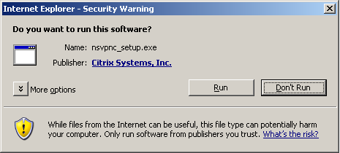

* 1. Select Install

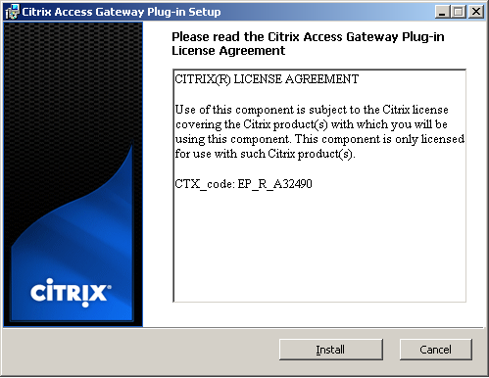

* 1. Select Finish when the installation process completes

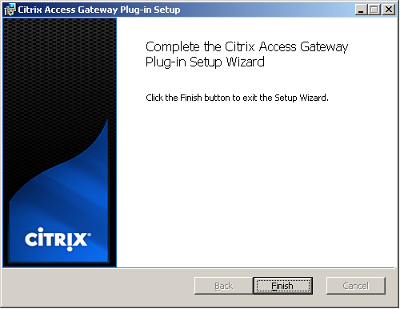

* 1. A window will appear when the connection process begins

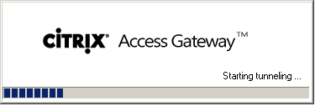

1. After login and authentication, you will be forwarded to a web page with various links and file shares depending on your group memberships. You can also create your own links.

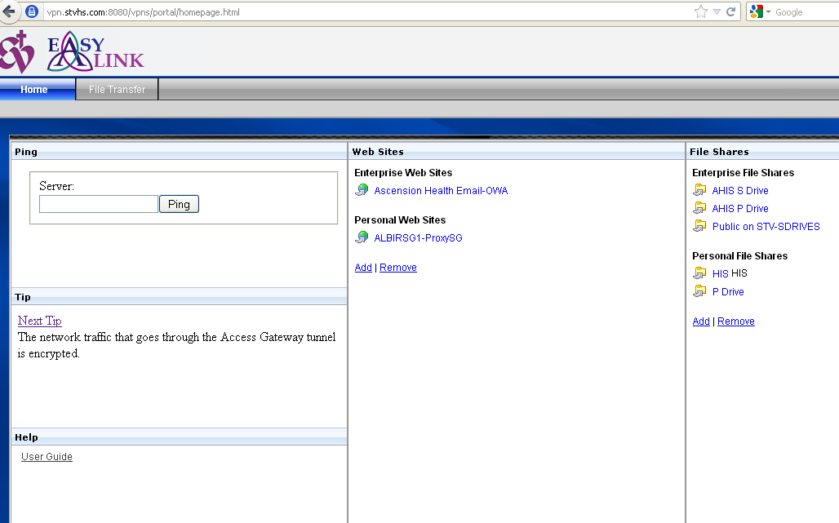

1. To verify connectivity to the VPN, locate the Citrix icon (circle with a lock in it) in the taskbar on the bottom right of your screen and ensure that the background of the icon is colored blue as in the image below.



To logout, right click the icon and select ‘Logoff’. The background of the icon will turn grey when you are no longer logged in.

1. Install the Citrix Online Plugin Full